12DDIT Photoshop Skills - Checklist for 2-3 lessons

In preparation for the upcoming assessments 2.42 Report (4 Credits) in Term 1 and 2.4 Prototype (6 Credits) in Term 2 you need to be comfortable with the following Photoshop tools and techniques. At the end of every lesson we will spend 5 minutes on reviewing what we have learnt in Photoshop. Complete the table once you have done an exercise that uses the tools or technique. Take a “print screen” of your exercise as a reminder of how to use this tool or technique as this will help you in your 2.42 Report (4 Credits) and 2.4 Prototype (6 Credits) assessments.

We will start with the “Yellow” highlighted Tools / Techniques first.

Tool / Technique | Used for: | Date
Polygonal Lasso | This tool allows us to use straight lines to select parts of a layer.
Magic Wand | This is an automatic selection tool that selects parts of a layer based on colours, where the tool is positioned, and the hardness of the tool. A harder tool will select more (be more lenient to colour differences).
Quick Selection Tool | This is like the magic wand tool, but it has been adjusted to allow the user to easily control the leniency of the tool by clicking and dragging over the areas that they want selected.
Magnetic Lasso | To select parts of an image by following an outline.
Pen Tool | To draw on the image.
RGB Colour | To set your image colour mode to RGB. This is the best colour mode for images that will be shared via computers.
Grey scale | This is a colour mode that will turn your image into shades of gray.
Duo Tones
History Palette | This allows you to see changes that you’ve made and revert them.
72 ppi (image resample) | This is the suggested pixel depth for images on a website.
PNG File for Transparent Backgrounds | This is a image file type typically used for graphics. It has limited colours but supports the use of transparency.
JPEG File for Images with a lot of Colour | This is a very compressed image file type that is typically used on the web. It supports more colours than PNG, but does not support transparency.
Curves
Brightness/Contrast | This allows us to adjust the colours so that they are brighter, or are more contrasting (have sharper outlines)
Free Transform | Free transform allows us to adjust the size and position of a layer and content on that layer.
Artistic Filter effects (RGB Mode only) | This allows us to add cool effects to our project to simply make it look better.
Erase Background Tool | A quick way of deleting a solid “flat” colour background. Using the Background Erase Tool, select brush size, then middle eye dropper tool to select the “mid tones” of your colour you want to delect.
Multiply blend mode | 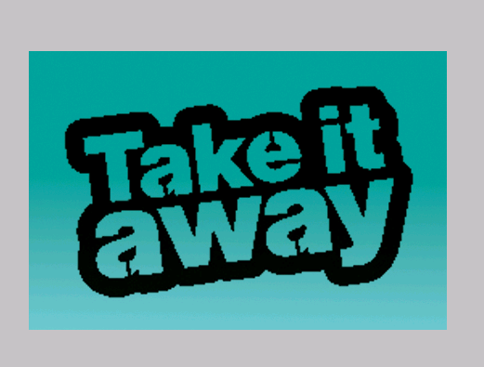  Layer “Multiply” Mode option on the layers palette to make the top layer blend into the 2nd layer. Efficient way of cutting out/blending the inside of a black and white logo with a website banner background colour.
Layer blends | 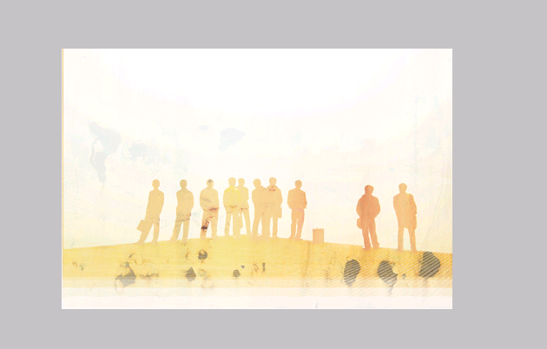  Layer blend Mode, using the “screen” option on the layers palette to make the top layer blend into the 2nd layer.

